Test Project document
  - WSC2017_TP40_Day3_EN

Submitted by:
Name: External Designer
Member country or region: N/A

Contents

This Test Project proposal consists of the following documentation/files:
- WSC2017_TP40_NO_EN.doc
- No images or text files needed or provided.
- Presentation on competition day

Introduction
The customer for this test project will be introduced on competition day 3 during the briefing presentation.

Description of project and tasks
Final description of packaging product will be introduced on competition day 3 during the briefing presentation.

Instructions to the Competitor
The task is vector only, to be created in Illustrator.
Target group: children all over the world age 9–15.

Task 1 & 2 must fit on 1 sheet A3 paper

Artwork Colours: Pantone Solid Coated colours only
Dieline Colours: Spot colours only

A child between the ages of 9–15 must be able to assemble the tasks without assistance.
You must add arrows, numbers or other signs to explain the assembly of both tasks on the CUT layer. The instructions must be on the CUT spot colour on the CUT layer.
Include icons or illustrations for the CUT, FOLD & GLUE instructions. No text must be included.
Example:
      

Task 1
Any shape allowed.

The design must only be one sided.

CUT lines: spot colour, stroke weight 1pt on separate CUT layer in Illustrator and pdf.
Name colour and layer CUT LINES.

* sample showing cut lines on coloured background. You may choose any spot colour that will have enough contrast to your background colour

FOLD lines: Spot colour 0.5pt dashed line. On separate layer in Illustrator and pdf.
Name of colour and layer: FOLD LINES

* sample showing dashed fold line on colour background. You may choose any PMS colour that will have enough contrast to your background colour

GLUE: Indicate glue points with a circle — 0.5pt stroke only, no fill colour.
Use spot colour, name the colour and layer: GLUE
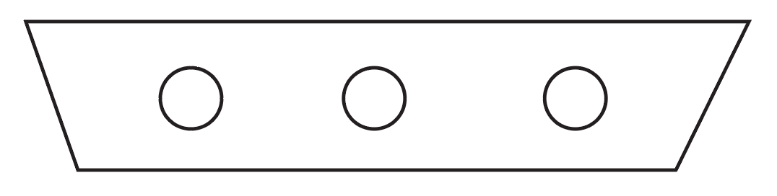

Bleed: 3 mm

Task 2:
(On the same A3 artboard as task 1)
You must make a front and back — but they must only use the one artboard (together with task 1).
Make them foldable any way you choose.
You can make either 2D or 3D, but they must be able to stand alone (self standing).

Use the same layers and colours for CUT LINES, FOLD LINES and GLUE as task 1.
No bleed required

You must deliver:
1 Illustrator file A3 artboard containing 5 layers
Layer: Task 1
Layer: Task 2
Layer: CUT LINES
Layer: FOLD LINES
Layer: GLUE

1 PDF/X-4:2010 with layers
Include your competitor number in the final file on CUT lines layer.

Task 1: assembled mock-up including prop placed inside package.
Task 2: assembled mock-ups.

